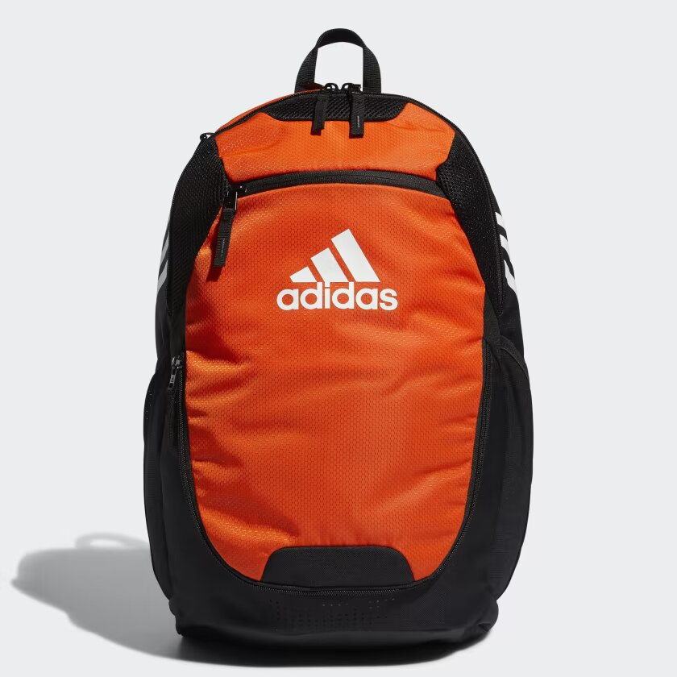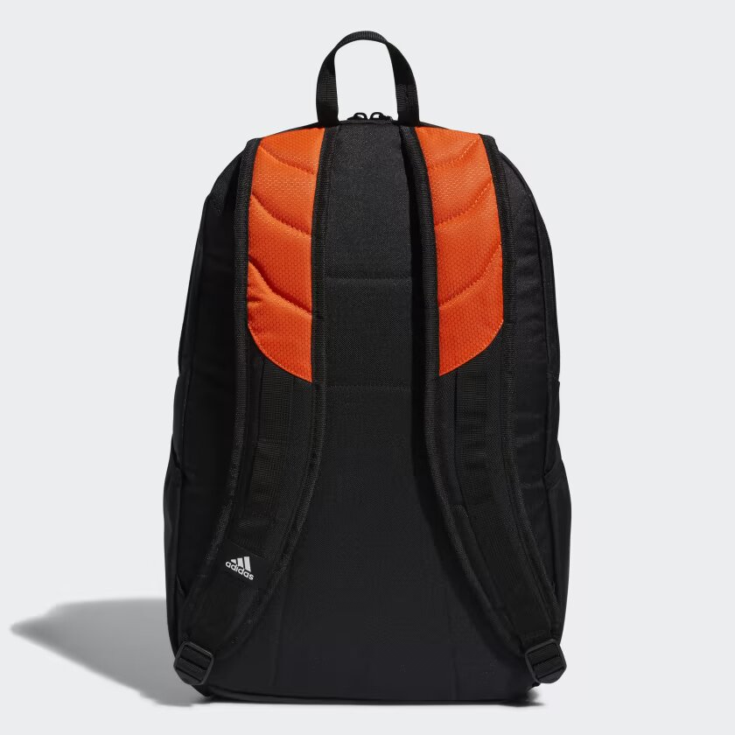

ADIDAS STADIUM BACKPACK

**A VERSATILE ADIDAS BACKPACK MADE IN PART WITH RECYCLED CONTENT.**

Keep all your workout gear separated and organized with this stadium backpack. Multiple pockets give you lots of options for carrying electronics, training shoes and water bottles. Worry less about wear and tear, thanks to a rugged ripstop build.

**DETAILS:**

* Dimensions: 11” x 10.5” x 19.5”
* Volume: 18.8 L
* 100% recycled polyester
* Durable mini-hexagon ripstop material
* Small pocket on front
* Two water bottle pockets and separate shoe pocket
* Two main compartments with zip closures
* Adjustable straps
* Imported
* Product color: Orange
* Product code: FZ6790